Req# - CI003

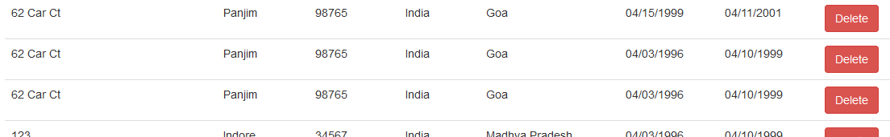

The user is able to enter same address twice. An error message should pop-up

The user is able to enter same dates twice. An error message should pop-up